**WEEK -4**

**(SPRING_REST_HANDSON)**

**Hands on 1**

**Create a Spring Web Project using Maven** 

**SpringLearnApplication.java**

**package** com.cognizant.spring_learn;

**import** org.springframework.boot.SpringApplication;

**import** org.springframework.boot.autoconfigure.SpringBootApplication;

@SpringBootApplication

**public** **class** SpringLearnApplication {

**public** **static** **void** main(String[] args) {

System.***out***.println("Starting SpringLearnApplication...");

SpringApplication.*run*(SpringLearnApplication.**class**, args);

}

}

**SpringLearnApplicationTests.java:**

package com.cognizant.spring_learn;

import org.junit.jupiter.api.Test;

import org.springframework.boot.test.context.SpringBootTest;

@SpringBootTest

class SpringLearnApplicationTests {

@Test

void contextLoads() {

}

}

**Pom.xml**

<?xml version="1.0" encoding="UTF-8"?>

<project xmlns="http://maven.apache.org/POM/4.0.0" xmlns:xsi="http://www.w3.org/2001/XMLSchema-instance"

xsi:schemaLocation="http://maven.apache.org/POM/4.0.0 https://maven.apache.org/xsd/maven-4.0.0.xsd">

<modelVersion>4.0.0</modelVersion>

<parent>

<groupId>org.springframework.boot</groupId>

<artifactId>spring-boot-starter-parent</artifactId>

<version>3.5.3</version>

<relativePath/> <!-- lookup parent from repository -->

</parent>

<groupId>com.cognizant</groupId>

<artifactId>spring-learn</artifactId>

<version>0.0.1-SNAPSHOT</version>

<name>spring-learn</name>

<description>Demo project for Spring Boot</description>

<url/>

<licenses>

<license/>

</licenses>

<developers>

<developer/>

</developers>

<scm>

<connection/>

<developerConnection/>

<tag/>

<url/>

</scm>

<properties>

<java.version>17</java.version>

</properties>

<dependencies>

<dependency>

<groupId>org.springframework.boot</groupId>

<artifactId>spring-boot-starter-web</artifactId>

</dependency>

<dependency>

<groupId>org.springframework.boot</groupId>

<artifactId>spring-boot-devtools</artifactId>

<scope>runtime</scope>

<optional>true</optional>

</dependency>

<dependency>

<groupId>org.springframework.boot</groupId>

<artifactId>spring-boot-starter-test</artifactId>

<scope>test</scope>

</dependency>

</dependencies>

<build>

<plugins>

<plugin>

<groupId>org.springframework.boot</groupId>

<artifactId>spring-boot-maven-plugin</artifactId>

</plugin>

</plugins>

</build>

</project>

**Output:**

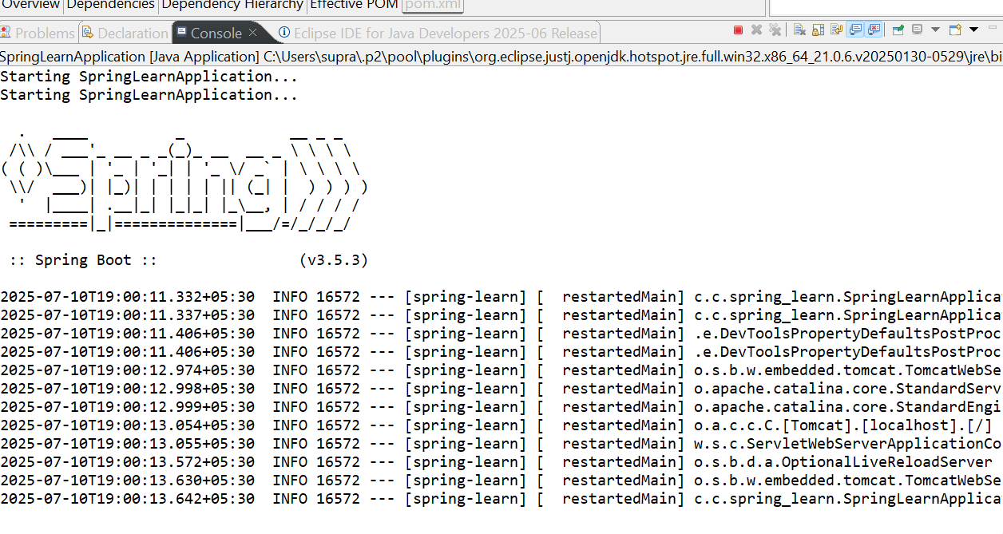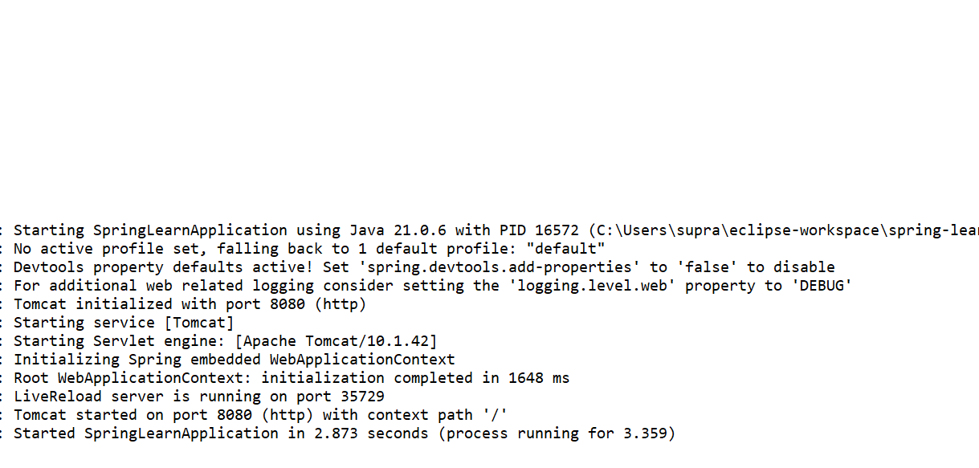

**Spring Core – Load Country from Spring Configuration. XML**

**Country.java**

package com.cognizant.springlearn;

import org.slf4j.Logger;

import org.slf4j.LoggerFactory;

public class Country {

private String code;

private String name;

private static final Logger LOGGER = LoggerFactory.getLogger(Country.class);

public Country() {

LOGGER.debug("Inside Country Constructor.");

}

public String getCode() {

LOGGER.debug("Inside getCode");

return code;

}

public void setCode(String code) {

LOGGER.debug("Inside setCode");

this.code = code;

}

public String getName() {

LOGGER.debug("Inside getName");

return name;

}

public void setName(String name) {

LOGGER.debug("Inside setName");

this.name = name;

}

@Override

public String toString() {

return "Country [code=" + code + ", name=" + name + "]";

}

}

**SpringLearnApplication.java**

**package** com.cognizant.springlearn;

**import** org.slf4j.Logger;

**import** org.slf4j.LoggerFactory;

**import** org.springframework.context.ApplicationContext;

**import** org.springframework.context.support.ClassPathXmlApplicationContext;

**public** **class** SpringLearnApplication {

@SuppressWarnings("unused")

**private** **static** **final** Logger ***LOGGER*** = LoggerFactory.*getLogger*(SpringLearnApplication.**class**);

**public** **static** **void** main(String[] args) {

*displayCountry*();

}

@SuppressWarnings("resource")

**public** **static** **void** displayCountry() {

System.***out***.println("==== Inside displayCountry ====");

**try** {

ApplicationContext context = **new** ClassPathXmlApplicationContext("country.xml");

Country country = context.getBean("country", Country.**class**);

System.***out***.println("==== Country Loaded ====");

System.***out***.println(country.toString());

} **catch** (Exception e) {

e.printStackTrace();

}

}

}

**Country.xml**

<?xml version="1.0" encoding="UTF-8"?>

<beans xmlns="http://www.springframework.org/schema/beans"

xmlns:xsi="http://www.w3.org/2001/XMLSchema-instance"

xsi:schemaLocation="

http://www.springframework.org/schema/beans

https://www.springframework.org/schema/beans/spring-beans.xsd">

<bean id="country" class="com.cognizant.springlearn.Country">

<property name="code" value="IN"/>

<property name="name" value="India"/>

</bean>

</beans>

**POM.xml**

<?xml version="1.0" encoding="UTF-8"?>

<project xmlns="http://maven.apache.org/POM/4.0.0" xmlns:xsi="http://www.w3.org/2001/XMLSchema-instance"

xsi:schemaLocation="http://maven.apache.org/POM/4.0.0 https://maven.apache.org/xsd/maven-4.0.0.xsd">

<modelVersion>4.0.0</modelVersion>

<parent>

<groupId>org.springframework.boot</groupId>

<artifactId>spring-boot-starter-parent</artifactId>

<version>3.5.3</version>

<relativePath/> <!-- lookup parent from repository -->

</parent>

<groupId>com.cognizant</groupId>

<artifactId>spring-learn</artifactId>

<version>0.0.1-SNAPSHOT</version>

<name>spring-learn</name>

<description>Demo project for Spring Boot</description>

<url/>

<licenses>

<license/>

</licenses>

<developers>

<developer/>

</developers>

<scm>

<connection/>

<developerConnection/>

<tag/>

<url/>

</scm>

<properties>

<java.version>17</java.version>

</properties>

<dependencies>

<dependency>

<groupId>org.springframework.boot</groupId>

<artifactId>spring-boot-starter-web</artifactId>

</dependency>

<dependency>

<groupId>org.springframework.boot</groupId>

<artifactId>spring-boot-devtools</artifactId>

<scope>runtime</scope>

<optional>true</optional>

</dependency>

<dependency>

<groupId>org.springframework.boot</groupId>

<artifactId>spring-boot-starter-test</artifactId>

<scope>test</scope>

</dependency>

<!-- Spring Core Dependency -->

<dependency>

<groupId>org.springframework</groupId>

<artifactId>spring-context</artifactId>

<version>5.3.34</version>

</dependency>

<!-- SLF4J for Logging -->

<dependency>

<groupId>org.slf4j</groupId>

<artifactId>slf4j-api</artifactId>

<version>1.7.36</version>

</dependency>

<dependency>

<groupId>org.slf4j</groupId>

<artifactId>slf4j-simple</artifactId>

<version>1.7.36</version>

</dependency>

</dependencies>

<build>

<plugins>

<plugin>

<groupId>org.springframework.boot</groupId>

<artifactId>spring-boot-maven-plugin</artifactId>

</plugin>

</plugins>

</build>

</project>

**OUTPUT:**

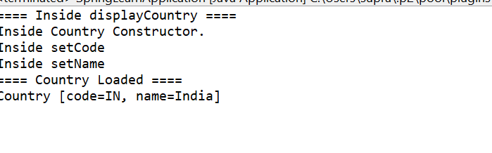

**2. Spring-rest-handson**

**Hello World RESTful Web Service**

**SpringLearnApplication.java**

**package** com.cognizant.springlearn;

**import** org.slf4j.Logger;

**import** org.slf4j.LoggerFactory;

**import** org.springframework.boot.SpringApplication;

**import** org.springframework.boot.autoconfigure.SpringBootApplication;

@SpringBootApplication

**public** **class** SpringLearnApplication {

**private** **static** **final** Logger ***LOGGER*** = LoggerFactory.*getLogger*(SpringLearnApplication.**class**);

**public** **static** **void** main(String[] args) {

***LOGGER***.debug("START main()");

SpringApplication.*run*(SpringLearnApplication.**class**, args);

***LOGGER***.debug("END main()");

}

}

**HelloController.java**

**package** com.cognizant.springlearn.controller;

**import** org.slf4j.Logger;

**import** org.slf4j.LoggerFactory;

**import** org.springframework.web.bind.annotation.GetMapping;

**import** org.springframework.web.bind.annotation.RestController;

@RestController

**public** **class** HelloController {

**private** **static** **final** Logger ***LOGGER*** = LoggerFactory.*getLogger*(HelloController.**class**);

@GetMapping("/hello")

**public** String sayHello() {

***LOGGER***.debug("START sayHello()");

String message = "Hello World!!";

***LOGGER***.debug("END sayHello()");

**return** message;

}

}

**Pox.xml**

<?xml version="1.0" encoding="UTF-8"?>

<project xmlns="http://maven.apache.org/POM/4.0.0" xmlns:xsi="http://www.w3.org/2001/XMLSchema-instance"

xsi:schemaLocation="http://maven.apache.org/POM/4.0.0 https://maven.apache.org/xsd/maven-4.0.0.xsd">

<modelVersion>4.0.0</modelVersion>

<parent>

<groupId>org.springframework.boot</groupId>

<artifactId>spring-boot-starter-parent</artifactId>

<version>3.5.3</version>

<relativePath/> <!-- lookup parent from repository -->

</parent>

<groupId>com.cognizant</groupId>

<artifactId>spring-learn</artifactId>

<version>0.0.1-SNAPSHOT</version>

<name>spring-learn</name>

<description>Demo project for Spring Boot</description>

<url/>

<licenses>

<license/>

</licenses>

<developers>

<developer/>

</developers>

<scm>

<connection/>

<developerConnection/>

<tag/>

<url/>

</scm>

<properties>

<java.version>17</java.version>

</properties>

<dependencies>

<!-- Spring Boot Starter Web -->

<dependency>

<groupId>org.springframework.boot</groupId>

<artifactId>spring-boot-starter-web</artifactId>

</dependency>

<!-- Spring Boot Starter Logging (uses SLF4J + Logback) -->

<dependency>

<groupId>org.springframework.boot</groupId>

<artifactId>spring-boot-starter-logging</artifactId>

</dependency>

<!-- Spring Boot Starter Test (Optional) -->

<dependency>

<groupId>org.springframework.boot</groupId>

<artifactId>spring-boot-starter-test</artifactId>

<scope>test</scope>

</dependency>

</dependencies>

<build>

<plugins>

<!-- Spring Boot Maven Plugin -->

<plugin>

<groupId>org.springframework.boot</groupId>

<artifactId>spring-boot-maven-plugin</artifactId>

</plugin>

</plugins>

</build>

**OUTPUT:** 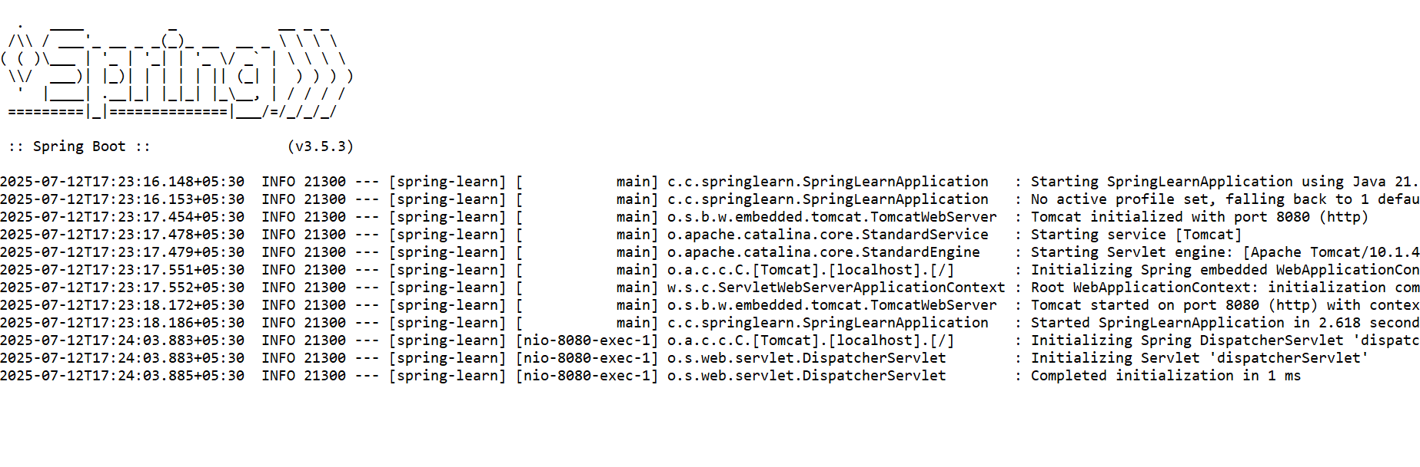

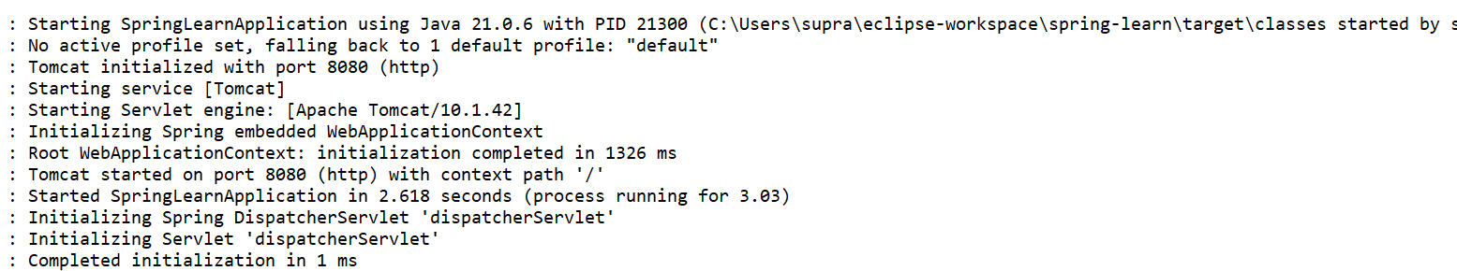

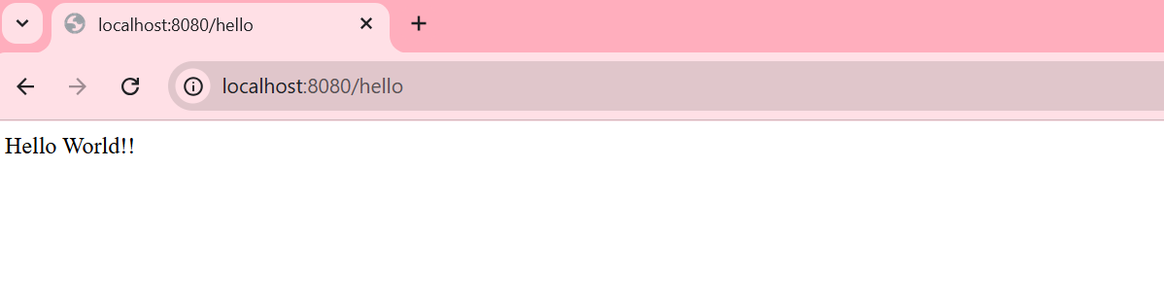

**REST - Country Web Service**

**Country.java**

**package** com.cognizant.springlearn;

**public** **class** Country {

**private** String code;

**private** String name;

**public** Country() {}

**public** String getCode() {

**return** code;

}

**public** **void** setCode(String code) {

**this**.code = code;

}

**public** String getName() {

**return** name;

}

**public** **void** setName(String name) {

**this**.name = name;

}

@Override

**public** String toString() {

**return** "Country [code=" + code + ", name=" + name + "]";

}

}

**SpringLearnApplication.java**

**package** com.cognizant.springlearn;

**import** org.springframework.boot.SpringApplication;

**import** org.springframework.boot.autoconfigure.SpringBootApplication;

@SpringBootApplication

**public** **class** SpringLearnApplication {

**public** **static** **void** main(String[] args) {

SpringApplication.*run*(SpringLearnApplication.**class**, args);

}

}

CountryController.java

**package** com.cognizant.springlearn.controller;

**import** com.cognizant.springlearn.Country;

**import** org.slf4j.Logger;

**import** org.slf4j.LoggerFactory;

**import** org.springframework.context.ApplicationContext;

**import** org.springframework.context.support.ClassPathXmlApplicationContext;

**import** org.springframework.web.bind.annotation.RequestMapping;

**import** org.springframework.web.bind.annotation.RestController;

@RestController

**public** **class** CountryController {

**private** **static** **final** Logger ***LOGGER*** = LoggerFactory.*getLogger*(CountryController.**class**);

@RequestMapping("/country")

**public** Country getCountryIndia() {

***LOGGER***.debug("START getCountryIndia()");

ApplicationContext context = **new** ClassPathXmlApplicationContext("country.xml");

Country country = context.getBean("country", Country.**class**);

***LOGGER***.debug("END getCountryIndia()");

**return** country;

}

}

**Application.properties**

spring.application.name=spring-learn

server.port=8083

**Country.xml**

<?xml version="1.0" encoding="UTF-8"?>

<beans xmlns="http://www.springframework.org/schema/beans"

xmlns:xsi="http://www.w3.org/2001/XMLSchema-instance"

xsi:schemaLocation="

http://www.springframework.org/schema/beans

https://www.springframework.org/schema/beans/spring-beans.xsd">

<bean id="country" class="com.cognizant.springlearn.Country">

<property name="code" value="IN"/>

<property name="name" value="India"/>

</bean>

</beans>

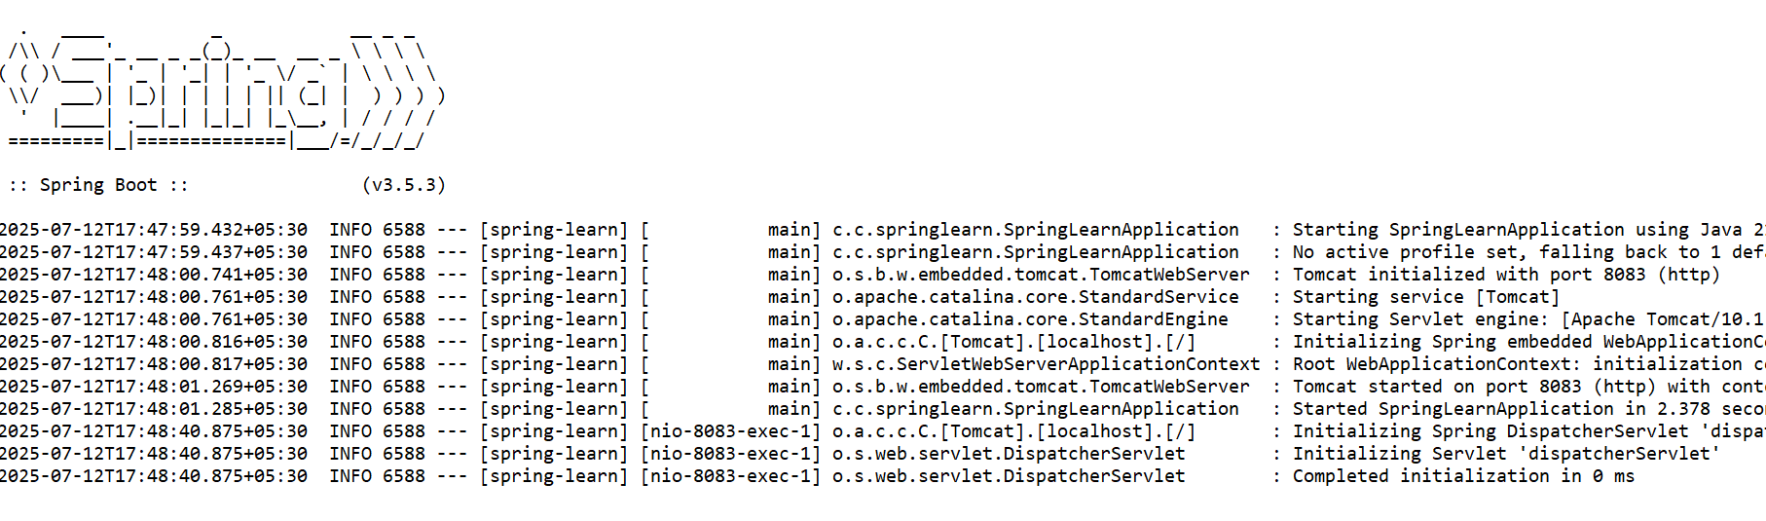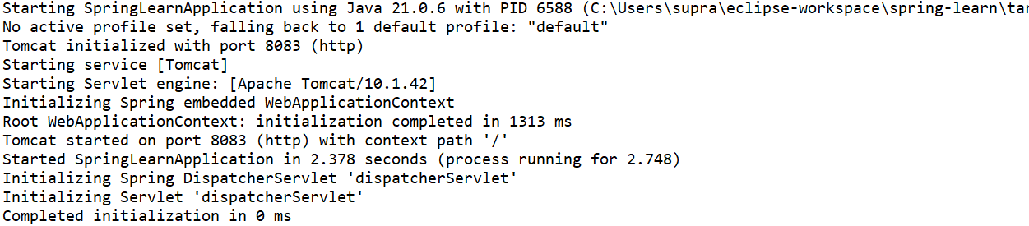

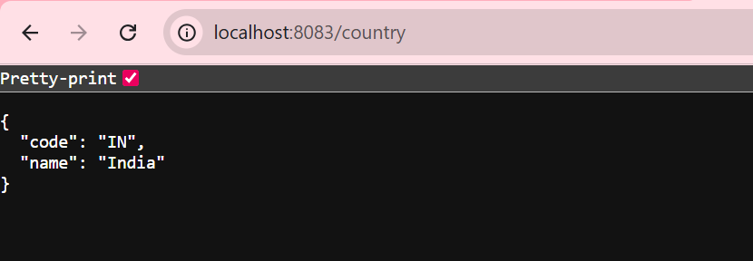

**REST - Get country based on country code**   
country.xml

<?xml version="1.0" encoding="UTF-8"?>

<beans xmlns="http://www.springframework.org/schema/beans"

xmlns:xsi="http://www.w3.org/2001/XMLSchema-instance"

xmlns:util="http://www.springframework.org/schema/util"

xsi:schemaLocation="

http://www.springframework.org/schema/beans https://www.springframework.org/schema/beans/spring-beans.xsd

http://www.springframework.org/schema/util https://www.springframework.org/schema/util/spring-util.xsd">

<bean id="countryIN" class="com.cognizant.springlearn.Country">

<property name="code" value="IN"/>

<property name="name" value="India"/>

</bean>

<bean id="countryUS" class="com.cognizant.springlearn.Country">

<property name="code" value="US"/>

<property name="name" value="United States"/>

</bean>

<bean id="countryJP" class="com.cognizant.springlearn.Country">

<property name="code" value="JP"/>

<property name="name" value="Japan"/>

</bean>

<bean id="countryDE" class="com.cognizant.springlearn.Country">

<property name="code" value="DE"/>

<property name="name" value="Germany"/>

</bean>

<!-- List of all countries -->

<util:list id="countryList">

<ref bean="countryIN"/>

<ref bean="countryUS"/>

<ref bean="countryJP"/>

<ref bean="countryDE"/>

</util:list>

</beans>

CountryService.java

**package** com.cognizant.springlearn.service;

**import** com.cognizant.springlearn.Country;

**import** org.springframework.context.ApplicationContext;

**import** org.springframework.context.support.ClassPathXmlApplicationContext;

**import** org.springframework.stereotype.Service;

**import** java.util.List;

@Service

**public** **class** CountryService {

**public** Country getCountry(String code) {

ApplicationContext context = **new** ClassPathXmlApplicationContext("country.xml");

@SuppressWarnings("unchecked")

List<Country> countryList = (List<Country>) context.getBean("countryList");

**return** countryList.stream()

.filter(c -> c.getCode().equalsIgnoreCase(code))

.findFirst()

.orElse(**null**);

}

}

CountryController.java

**package** com.cognizant.springlearn.controller;

**import** com.cognizant.springlearn.Country;

**import** com.cognizant.springlearn.service.CountryService;

**import** org.slf4j.Logger;

**import** org.slf4j.LoggerFactory;

**import** org.springframework.beans.factory.annotation.Autowired;

**import** org.springframework.web.bind.annotation.*;

@RestController

**public** **class** CountryController {

**private** **static** **final** Logger ***LOGGER*** = LoggerFactory.*getLogger*(CountryController.**class**);

@Autowired

**private** CountryService countryService;

@GetMapping("/country/{code}")

**public** Country getCountry(@PathVariable String code) {

***LOGGER***.debug("START getCountry() with code: {}", code);

Country country = countryService.getCountry(code);

***LOGGER***.debug("END getCountry()");

**return** country;

}

}

SpringLearnApplication.java

package com.cognizant.springlearn;

import org.springframework.boot.SpringApplication;

import org.springframework.boot.autoconfigure.SpringBootApplication;

@SpringBootApplication

public class SpringLearnApplication {

public static void main(String[] args) {

SpringApplication.run(SpringLearnApplication.class, args);

}

}

OUTPUT: 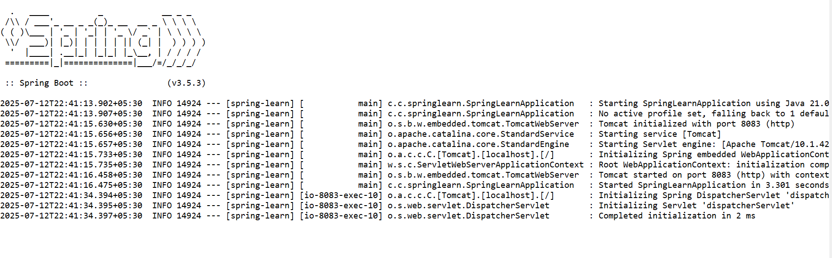



**Create authentication service that returns JWT**

**pom.xml**

<!-- Spring Boot Starter Security -->

<dependency>

<groupId>org.springframework.boot</groupId>

<artifactId>spring-boot-starter-security</artifactId>

</dependency>

<!-- JJWT: JSON Web Token (JWT) -->

<dependency>

<groupId>io.jsonwebtoken</groupId>

<artifactId>jjwt</artifactId>

<version>0.9.1</version>

</dependency>

**AuthenticationController.java**

package com.cognizant.springlearn.controller;

import com.cognizant.springlearn.util.JwtUtil;

import org.springframework.beans.factory.annotation.Autowired;

import org.springframework.http.ResponseEntity;

import org.springframework.web.bind.annotation.*;

import java.util.Base64;

import javax.servlet.http.HttpServletRequest;

@RestController

public class AuthenticationController {

@Autowired

private JwtUtil jwtUtil;

@GetMapping("/authenticate")

public ResponseEntity<?> generateToken(HttpServletRequest request) {

String authHeader = request.getHeader("Authorization");

if (authHeader != null && authHeader.startsWith("Basic ")) {

String base64Credentials = authHeader.substring("Basic ".length());

byte[] credDecoded = Base64.getDecoder().decode(base64Credentials);

String credentials = new String(credDecoded);

String[] values = credentials.split(":", 2);

String username = values[0];

String password = values[1];

// Hardcoded validation (in real use, check DB or UserDetailsService)

if ("user".equals(username) && "pwd".equals(password)) {

String token = jwtUtil.generateToken(username);

return ResponseEntity.ok().body("{\"token\":\"" + token + "\"}");

} else {

return ResponseEntity.status(401).body("Invalid Credentials");

}

}

return ResponseEntity.status(400).body("Missing Authorization header");

}

}

**SecurityConfig.java**

package com.cognizant.springlearn.config;

import org.springframework.context.annotation.Configuration;

import org.springframework.security.config.annotation.web.builders.HttpSecurity;

import org.springframework.security.config.annotation.web.configuration.WebSecurityConfigurerAdapter;

@SuppressWarnings("deprecation")

@Configuration

public class SecurityConfig extends WebSecurityConfigurerAdapter {

@Override

protected void configure(HttpSecurity http) throws Exception {

http

.csrf().disable()

.authorizeRequests()

.antMatchers("/authenticate").permitAll()

.anyRequest().authenticated()

.and()

.httpBasic(); // Enable basic auth for /authenticate

}

}

**OUTPUT:**

